Rolling Mill Predictor – A Machine Learning Model

Submitted by:  
Neha Jadhav  
  
Education Program:  
Bachelor of Technology (B.Tech) in Artificial Intelligence & Machine Learning

University:

Chhatrapati Shivaji Maharaj University  
  
Class:  
Third Year – Semester VI  
  
Internship Dates:  
March 2025 – April 2025  
  
Internship Organisation:  
Tata Steel – Department of Information Technology

**Table of Contents**

|  |  |
| --- | --- |
| 1. | Acknowledgement |
| 2. | Company Overview – Tata Steel |
| 3. | Information about the Internship Position |
| 4. | Internship Experience |
| 5. | About the Project |
| 6. | Project Description – Rolling Mill Predictor |
| 7. | How the Model Works |
| 8. | Technologies Used |
| 9. | Screenshots |
| 10. | Conclusion |

1. Acknowledgement

I would like to extend my heartfelt gratitude to my mentor at Tata Steel, Mr Manish Ghosh, for their constant guidance and support throughout my internship. I truly appreciate the opportunity to learn from such a talented team. A special thanks to everyone in the IT department for helping me navigate through challenges and providing the resources needed to work on my project. This internship has been a valuable experience, and I'm grateful for the exposure to both technical and real-world problems in the steel industry.

2. Company Overview – Tata Steel

Tata Steel, one of the world’s largest steel manufacturers, has been a major player in the industry for over a century. Founded in 1907, the company now operates in over 26 countries and employs over 80,000 people globally. Tata Steel is known not just for its high-quality steel products, but also for its commitment to sustainability and innovation. The company is always looking for ways to improve processes and reduce environmental impact, making it a leader in both the steel and manufacturing sectors.

3. Information about the Internship Position

During my internship at Tata Steel, I worked as an Intern in the Information Technology department, where I focused on applying machine learning techniques to enhance industrial processes. Specifically, my project revolved around improving the accuracy and efficiency of the rolling mill simulation process using data-driven insights. This internship gave me the chance to bridge the gap between theoretical knowledge and practical application in a real-world industrial setting.

4. Internship Experience Description

My time at Tata Steel was both challenging and rewarding. I had the chance to work on a real industrial problem, and it helped me see firsthand how machine learning can be integrated into manufacturing processes. I was responsible for developing a model that could predict key parameters in the rolling mill process—something that’s critical to steel production. Working alongside experienced professionals, I gained practical skills in Python programming, data processing, and applying machine learning techniques in an industrial context. This experience was eye-opening, and I’m excited to take what I’ve learned into future projects.

5. About the Project

## Project Title: Rolling Mill Predictor – A Machine Learning Model

* Problem statement: To create a machine learning model that predicts the necessary input thickness and number of passes required to achieve a desired output thickness in the rolling mill process.

The machine learning model was trained using historical data, enabling it to simulate the rolling mill process more realistically, without entirely relying on exact data matches. The result was an application that could predict these important parameters in a way that mimics real-world conditions.

6. Project Description – Rolling Mill Predictor

In the rolling mill process, steel material is reduced in thickness through multiple passes. Traditionally, this process is governed by rules based on historical data. However, this method doesn’t always account for the unpredictability and variations in the real world.

The Rolling Mill Predictor project used machine learning to take a given target output thickness and predict the corresponding input thickness and number of passes. The model learns from historical data but operates independently from it, allowing it to make predictions even when exact data matches aren’t available. The result is a more flexible and reliable tool for simulating the rolling mill process.

The application itself is built using Python and CustomTkinter, offering a simple and intuitive graphical interface. Users can input the desired output thickness, and the app will provide predictions for the necessary input thickness and number of passes required. This model can be used to simulate a variety of rolling mill scenarios, helping engineers optimize their processes.

7. How the Model Works

Here's how the application works, step-by-step:  
  
**1. User Input:** The user enters a desired PASS_OUTPUT_THICKNESS value (in mm) via the graphical interface.

**2. Validation**: The input is validated to ensure it is numeric and within the acceptable range (0.28 mm – 4.75 mm) according to min-max in the CSV file.

**3. ML Model Prediction:**  
 - A trained Random Forest Regression model predicts the PASS_INPUT_THICKNESS based on the target output.  
 - Another Random Forest model estimates the minimum number of passes (PASS_NO) required for this transformation.

**4. Reduction Logic:** Based on the predicted values, the model calculates the reduction in thickness for each pass using a realistic exponential reduction formula.

**5. Tabular Output:** The app displays a detailed table showing each pass, input and output thickness, reduction in mm, and reduction percentage.

**6. Graphs:**  
 - A line chart plots Thickness vs. Pass.  
 - A bar chart shows the percentage of reduction in each pass.

**7. Visualization:**

This helps users (especially engineers and operators) visually understand the reduction sequence in the rolling process.

**8. Models Used:**

Random Forest Regressor

The models were trained on actual rolling mill data, filtered and cleaned to meet physical and operational constraints. This tool serves as a decision-support system for optimizing the rolling process, reducing manual guesswork and increasing efficiency.

8. Technologies Used

* **Python:** The core programming language used to build the model and backend logic.
* **CustomTkinter:** Used to create an interactive and visually appealing graphical user interface (GUI).
* **Scikit-learn:** The machine learning library used to develop the predictive model.
* **Pandas & NumPy:** These libraries were crucial for processing and handling the data efficiently.
* **Matplotlib:** is a Python library used for creating static, animated, and interactive visualizations like charts and plots.

9. Screenshots

Below is a screenshot of the final model interface:

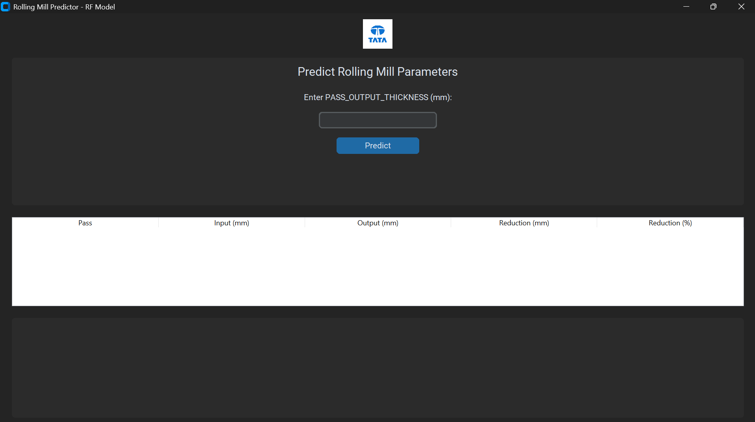

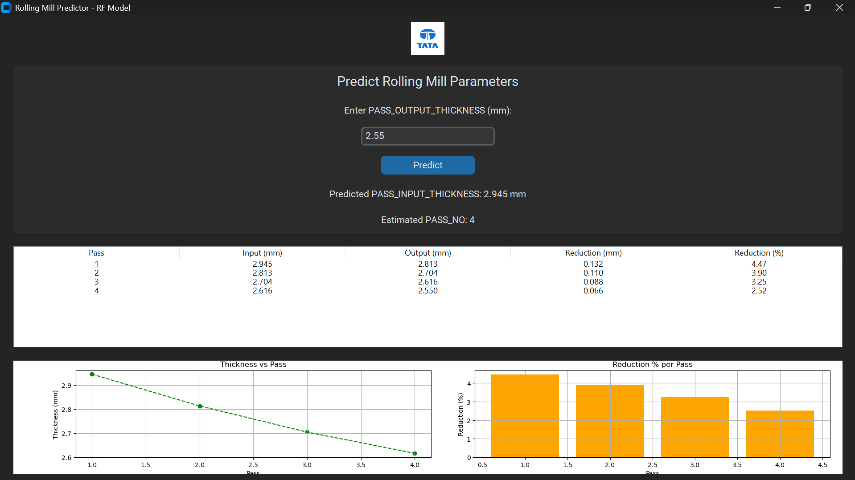

10. Conclusion

The Rolling Mill Predictor project was a fantastic opportunity to apply machine learning in a practical industrial setting. By creating a model that predicts the necessary input thickness and number of passes required for a given output thickness, the project improved the accuracy and flexibility of the rolling mill simulation process. This application could be a valuable tool for engineers in steel manufacturing, offering a more adaptable and accurate way to optimize the rolling process.

This experience has been an incredible learning opportunity, and I am thankful to Tata Steel for providing the resources and support needed to bring this project to life. The skills I’ve developed here will be invaluable as I continue to pursue a career in machine learning and industrial automation.